**DAILY ONLINE ACTIVITIES SUMMARY**

|  |  |  |  |  |  |  |  |
| --- | --- | --- | --- | --- | --- | --- | --- |
| **Date:** | **18/06/2020** | | | | **Name:** | **Churashma** | |
| **Sem & Sec** | **4th SEM 'A' Section** | | | | **USN:** | **4AL18CS019** | |
| **Online Test Summary** | | | | | | | |
| **Subject** | | **No test** | | | | | |
| **Max. Marks** | | **-** | | **Score** | | **-** | |
| **Certification Course Summary** | | | | | | | |
| **Course** | **Introduction to information security** | | | | | | |
| **Certificate Provider** | | | **greatlearning academy** | **Duration** | | | **5.5 hours** |
| **Coding Challenges** | | | | | | | |
| **Problem statement 1: Find the smallest positive integer value that cannot be represented as sum of any subset of a given array sorted in ascending order.**  **Problem statement 2: Write a C Program to generate first N Magic Numbers.** | | | | | | | |
| **Status: completed** | | | | | | | |
| **Uploaded the report in Github** | | | | **yes** | | | |
| **If yes Repository name** | | | | **https://github.com/Churashma/Lockdown-coding** | | | |
| **Uploaded the report in slack** | | | | **yes** | | | |

ONLINE TEST DETAILS: No test.

CERTIFICATION COURSE DETAILS: Today I studied about hash hack code: emerging trends in Cyber security. The exponential growth of the Internet interconnections has led to a significant growth of cyber attack incidents often with disastrous and grievous consequences. I completed watching all the videos of information security and I got certificate.

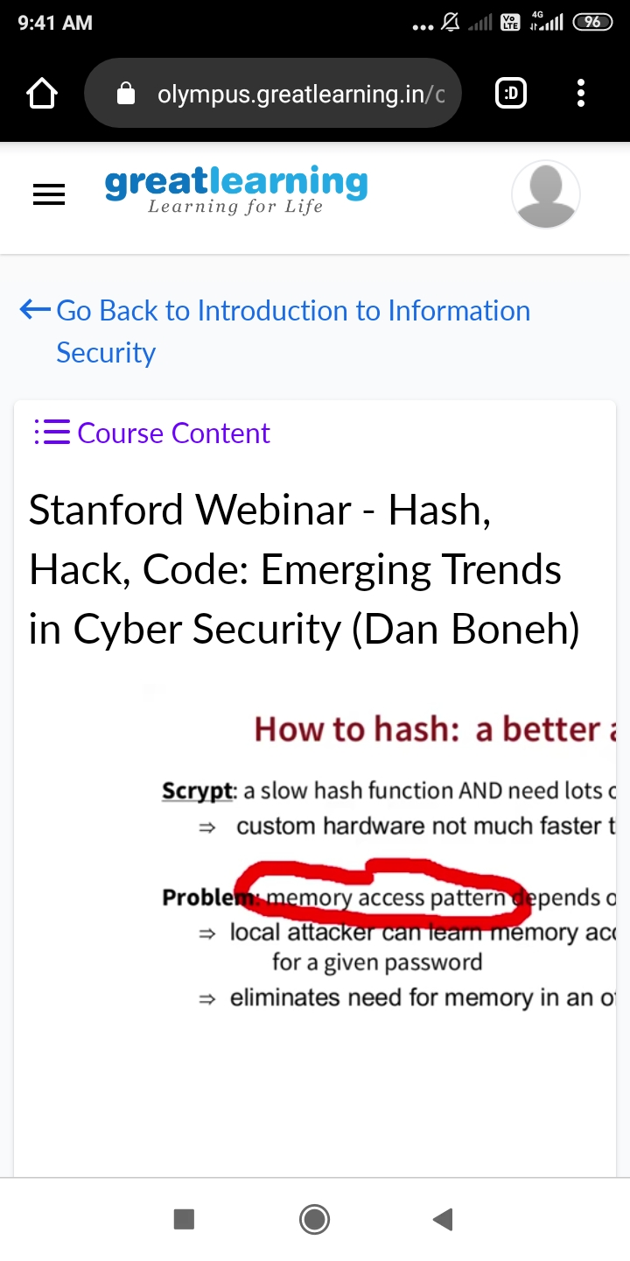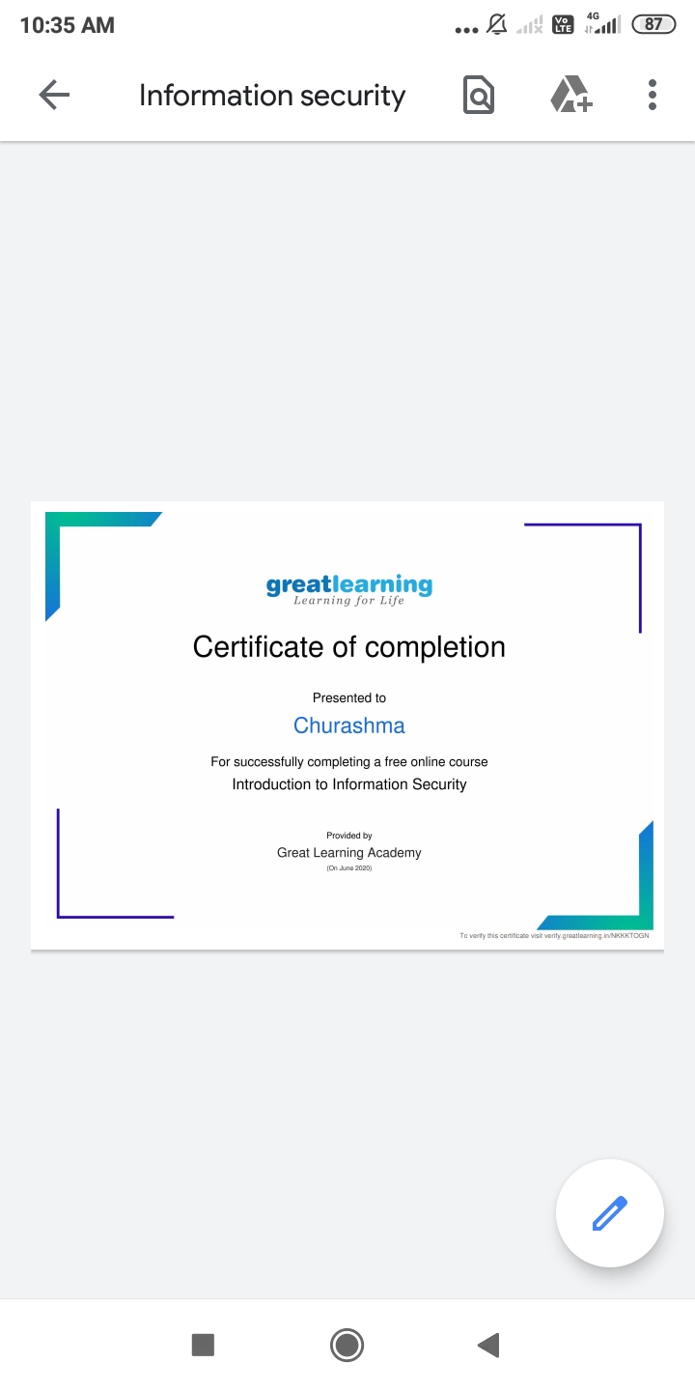

**CODING CHALLENGES DETAILS**:

**Problem statement 1:**  Find the smallest positive integer value that cannot be represented as sum of any subset of a given array sorted in ascending order.

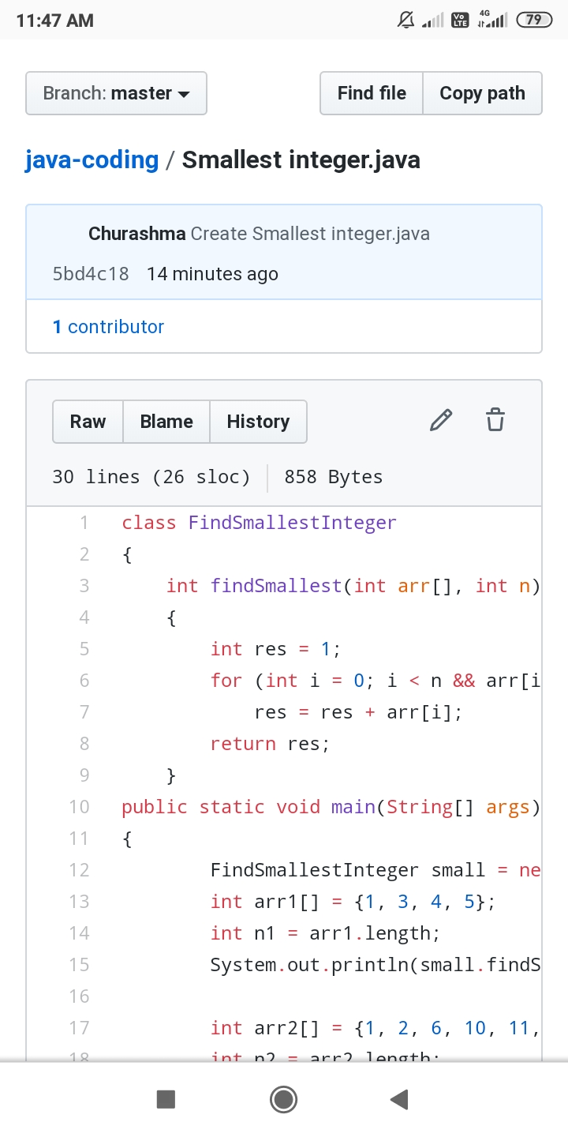

Problem statement 2: Write a C Program to generate first N Magic Numbers.

